# Assignment - 1

**Prajakta Mane (BE/A/B1821016)**

**Title:** Creating and visualizing neural networks for the given data.

## Objectives:

1. To handle given data for creating and visualizing neural network.
2. To analyze data using a python programming language.

## Software Requirement:

Windows /Linux

## Theory:

Neural network was inspired by the design and functioning of human brain and components

.

**Definition:**

―Information processing model that is inspired by the way biological nervous system (i.e thebrain) process information, is called Neural Network.

Neural Network has the ability to learn by examples. It is not designed to perform fix /specifictask, rather task which need thinking (e.g. Predictions).

ANN is composed of large number of highly interconnected processing elements(neurons)working in unison to solve problems. It mimic human brain.

With advanced in deep learning, you can now visualise the entire deep learning process or just the Convolutional Neural Network you’ve built.

We are going to build simple neural network using Keras and then use ANN visualizer to visualize our neural network.

**Basic Operation of a Neural Network:**



X1 and X2 – input neurons.Y- output neuron

Weighted interconnection links- W1 and W2.Net input calculation is :

Yin= x1w1+x2w2 Output is :

y=f(Yin) Output= function

ANN Visualizer:

is a python library that enables us to visualize an Artificial Neural Network using just a single line of code. It is used to work with Keras and makes use of python’s graphviz library to create a neat and presentable graph of the neural network you’re building.

**Visualize a Neural Network in Python using Graphviz**

* Import module.
* Create a new object of Diagraph.
* Add **node ()** and **edge ()** into graph object.
* Save the source code with render () object.

Code :

<https://colab.research.google.com/drive/1GZw41-uztFjQfoUbKCc53sYTip82e2by?usp=sharing>

# Output :

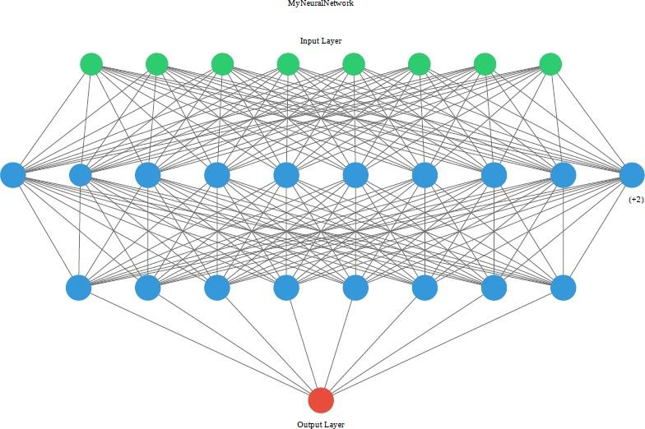

## Conclusion:

Here, we studied creating and visualizing neural network for the given data using

python.